February | 2025
Bolivar Pentecostal Church BPCHarpersFerry@gmail.com www.bpcharpersferry.com
Sunday | Monday | Tuesday | Wednesday | Thursday | Friday | Saturday
 |  |  |  |  |  | 1
MISSIONS SUNDAY 2 | 3 | 4 | 5 | 6 | 7 | 8
PSP @ 9:30am  Sun School 10am  Sun AM Worship 11am  Sun PM Worship 6pm | Prayer Meeting 9am | Prayer Meeting 9am | Prayer Meeting 9am  Bill Reed’s Viewing @ Eackles 6 – 8pm  Youth Service 8pm | Prayer Meeting 9am  Bill Reed’s Funeral & Lunch After 11am @ BPC | Prayer Meeting 9am  Pastor Eric’s Sound Of Truth Radio 12:30am & 1:30pm
OCC SOUP & 9 | 10 | 11 | 12 | 13 | 14 | 15
SANDWICH TO GO  PSP @ 9:30am  Sun School 10am  Sun AM Worship 11am  Youth Super Bowl Party @ 5:30pm | Prayer Meeting 9am | Prayer Meeting 9am  BOARD MEETING 6PM | Prayer Meeting 9am  Midweek Bible Study @ 6:30pm  Youth Service 8pm | Prayer Meeting 9am | Prayer Meeting 9am  Pastor Eric’s Sound Of Truth Radio 12:30am & 1:30pm
16 | 17 | 18 | 19 | 20 | 21 | 22
PSP @ 9:30am  Sun School 10am  Sun AM Worship 11am  Sun PM Worship 6pm | Prayer Meeting 9am | Prayer Meeting 9am  ANNA’S HEART 6PM | Prayer Meeting 9am  Midweek Bible Study @ 6:30pm  Youth Service 8pm | Prayer Meeting 9am  Men’s Fellowship 6:30pm | Prayer Meeting 9am  Pastor Eric’s Sound Of Truth Radio 12:30am & 1:30pm
23 | 24 | 25 | 26 | 27 | 28
PSP @ 9:30am  Sun School 10am  Guest Speaker 11am  NO PM WORSHIP | Prayer Meeting 9am | Prayer Meeting 9am | Prayer Meeting 9am  Midweek Bible Study @ 6:30pm  Youth Service 8pm | Prayer Meeting 9am | Prayer Meeting 9am  Pastor Eric’s Sound Of Truth Radio 12:30am & 1:30pm
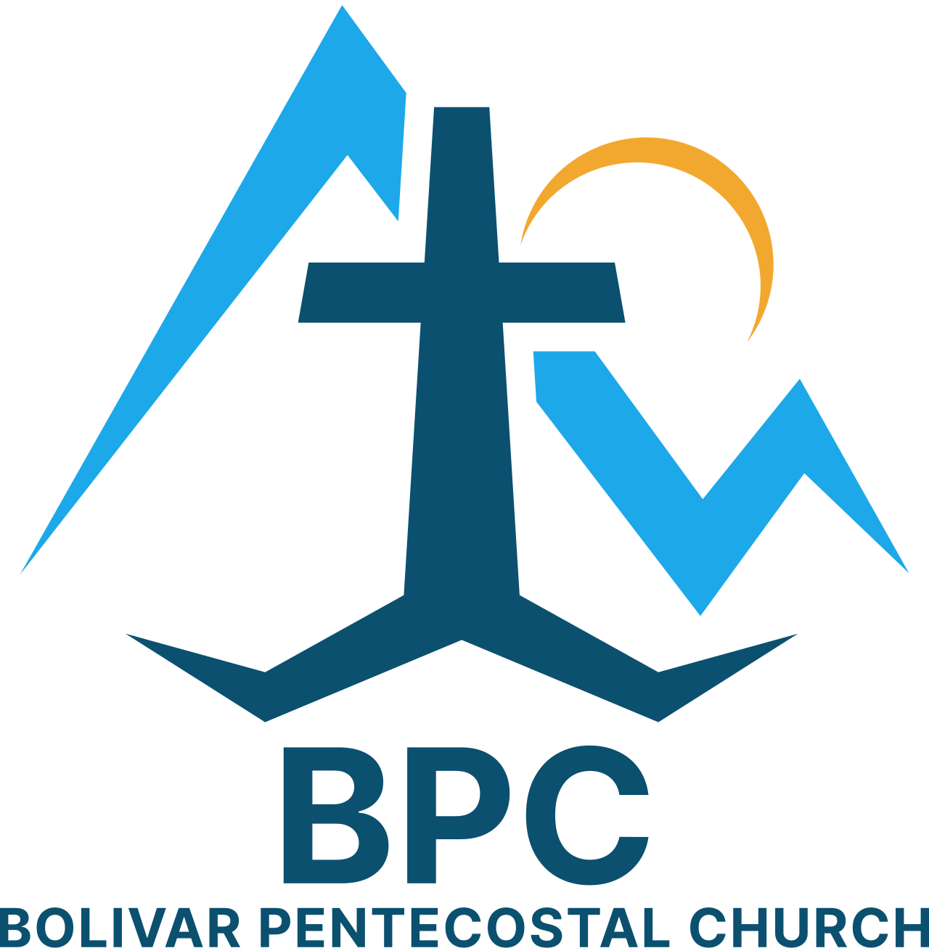 | BPC – Would YOU Help?  ____ OCC shoeboxes for 2025 – would you consider donating some?  ____ Donation towards Building Fund – Parking Lot,A/C Units, & Gutters  ____ Get involved in a Life Connection ministry team, if you’re not already | BPC’s Missions & World Evangelism Support – Will YOU Help?  ____ Ask God what He’d have you give monthly to Missions in 2025 & fill out a Faith Promise & place it in the offering  ____ Special offering on Missions Sunday in support of our Missionaries/Evangelists  ____ Pray regularly that God would give open doors of ministry to all the Missionaries/Evangelists we support | Special Projects You Can Help With:  ____ Kid’s Church big room clean-up & re-organizing  ____ Tear down old playground equipment in back of the church & haul to the dump  ____ Back Offices reorganized & bookshelves taken down
“Eye Has Not Seen, Nor Ear Heard, Neither Has Entered Into The Heart Of Man… What God Has In Store!” – I Corinthians 2:9

